You can use.Net Core C# or Python for your implementation.

We will evaluate your skills in object oriented programming and design. We expect the code to be **production-quality**, and can easily be maintained and evolved, not just a barebones algorithm.

Please commit your solution to <https://github.com/> and provide us link to your repo (do not create any security on this repo). **Do not** upload Zip/Rar files. Make sure that solution can be downloaded without any modifications. It would be a plus if you would have docker file in your solution as well.

**Programming Challenge:**

The Wikimedia Foundation provides all pageviews for Wikipedia site since 2015 in machine-readable format. The pageviews can be downloaded in gzip format and are aggregated per hour per page. Each hourly dump is approximately 50MB in gzipped text file and is somewhere between 100MB and 250MB in size unzipped.

Technical documentation of the service:

<https://wikitech.wikimedia.org/wiki/Analytics/Data_Lake/Traffic/Pageviews>

Sample link:

<https://dumps.wikimedia.org/other/pageviews/2015/2015-05/pageviews-20150501-010000.gz>

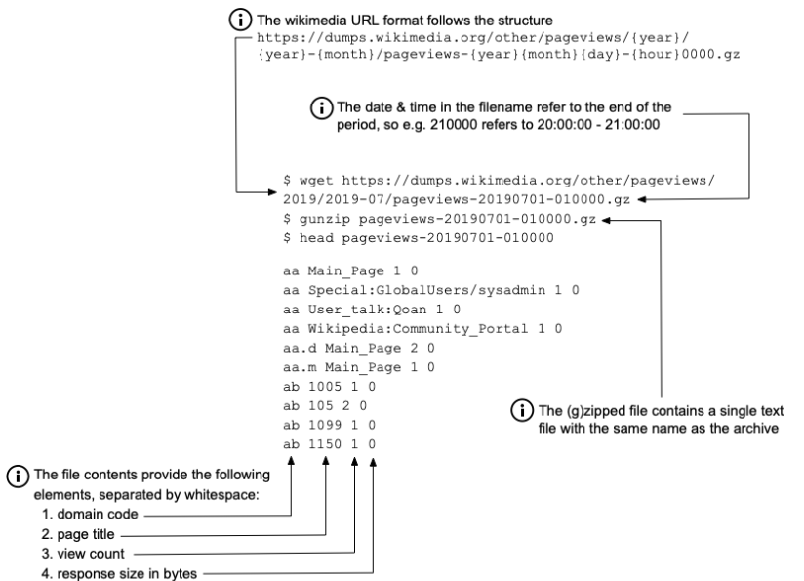

Please create a command line application.

Your code should get data for last 5 days and provide the following counts in file (grouped by **days**):

1. Language & Domain trailing part (see [technical documentation](https://wikitech.wikimedia.org/wiki/Analytics/Data_Lake/Traffic/Pageviews) for domain)
2. Page title with **max** count of views

Result of your execution should be printed in console like this:

Language & Domain count

**Period Language Domain ViewCount**

20210101 en wikipedia 2000

20210102 en wikimedia 5000

20210103 en wikinews 8000

20210104 zu wikipedia 10

20210105 zu wikimedia 15

Language page max view count

**Period Page ViewCount**

20210101 Apple_Watch 20200

20210102 Apple_Watch 10000

20210103 Google_Cloud 50200

20210104 Google_Cloud 70000

*>>what is "trailing part" means in task 1? should display the max view count (for language & domain combination) or should display by day each language & domain combination? I need help undertanding the criteria to filter the data*

**R: should display the max view count (for language & domain combination)**

*>>in the task 2 the max count should include all the languages sum or the max count of a language available for the page?*

**R: all the languages sum**

¿Cómo estás? Respecto a tu primera consulta, de acuerdo a las instrucciones: Result of your execution should be printed in console.